**Phase 3: Data Modeling & Relationships**

**Overview**

Phase 3 establishes the foundational Salesforce data model for the solution. This phase covers the creation and configuration of custom objects, fields, record types, layouts, relationships, and core data architecture required to support business processes for supply chain and inventory management.

**3.1 Standard & Custom Objects**

* Identified key business entities and created the following custom objects:
  + **Warehouse**
  + **Product**
  + **Supplier**
  + **Inventory**
  + **Purchase Order**
  + **Purchase Order Line Item**

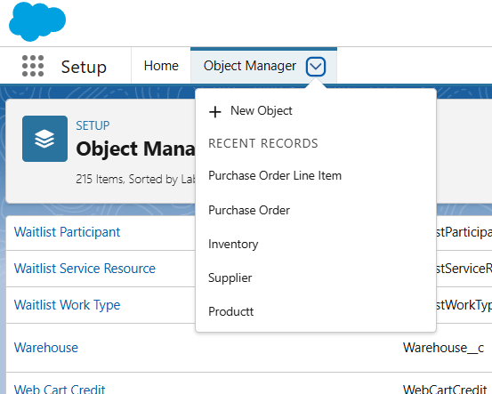

**3.2 Fields**

* For each object, custom fields were created to store relevant business data.
* Example fields include:
  + **Warehouse:** Location, Capacity, Manager, Status
  + **Product:** SKU, Category, Unit Price, Reorder Point, Status
  + **Supplier:** Contact Info, Rating, Payment Terms, Status
  + **Inventory:** Product (Lookup), Warehouse (Lookup), Current Stock, Reserved Stock, Cost Per Unit
  + **Purchase Order:** Supplier (Lookup), Warehouse (Lookup), Order Date, Expected Delivery, Status, Total Amount
  + **Purchase Order Line Item:** Purchase Order (Master-Detail), Product (Lookup), Quantity, Unit Price, Total Price
* Fields were configured with appropriate types (Number, Currency, Picklist, Lookup, Master-Detail, Formula).
* Example image

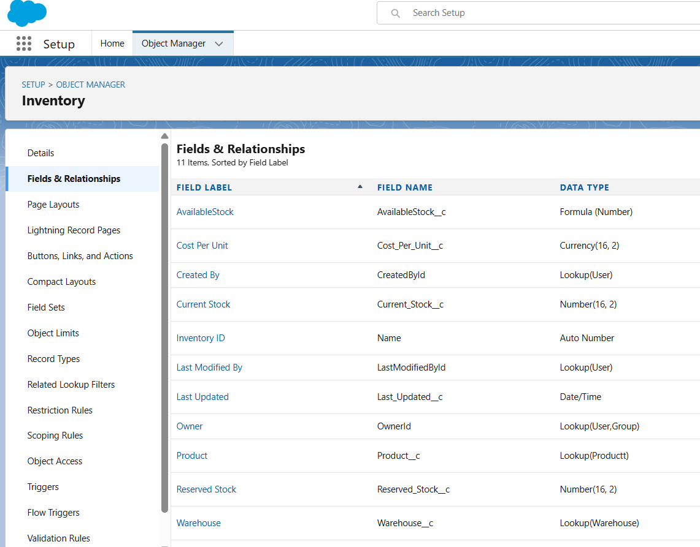

**3.3 Record Types**

* Created record types on suitable objects to segment different business processes.
  + Example: Purchase Order record types for Emergency, Standard, and Bulk.
* Assigned record types to relevant profiles to control available layouts and processes.

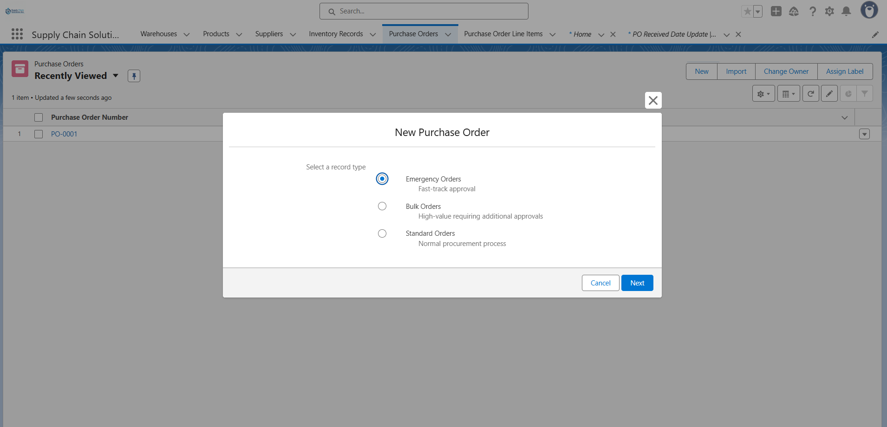

**3.4 Page Layouts & Compact Layouts**

* Designed page layouts for every object to optimize user data entry and record viewing:
  + Grouped fields into logical sections.
  + Configured related lists (e.g., Purchase Order Line Items attached to Purchase Orders).

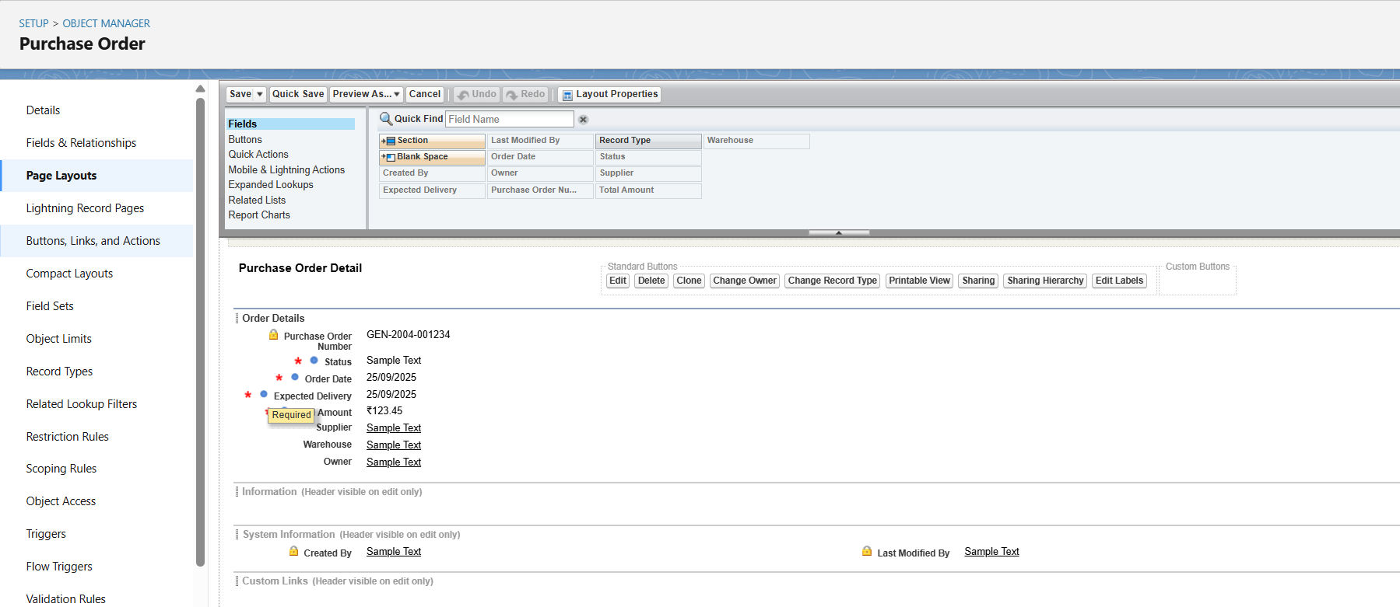

**3.5 Schema Builder**

* Used Salesforce Schema Builder for a visual overview of objects and direct relationships.
* Verified model completeness: ensuring all custom objects, lookup/master-detail fields, and junction objects properly connect core business data.

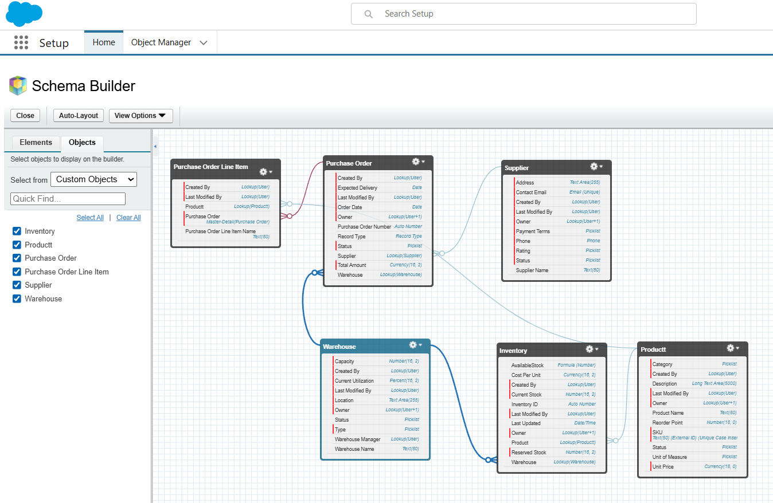

**3.6 Relationship Design**

* Implemented proper relationships between objects:
  + **Master-Detail:** Purchase Order Line Item → Purchase Order
  + **Lookup:** Inventory → Product; Inventory → Warehouse; Purchase Order → Supplier; Purchase Order → Warehouse
* Ensured referential integrity and configured related list visibility for parent records.

**3.7 Junction Objects**

* Developed junction objects for many-to-many relationships (e.g., multiple products per purchase order).
* Confirmed at least one master-detail relationship for each junction object to control record ownership and security.

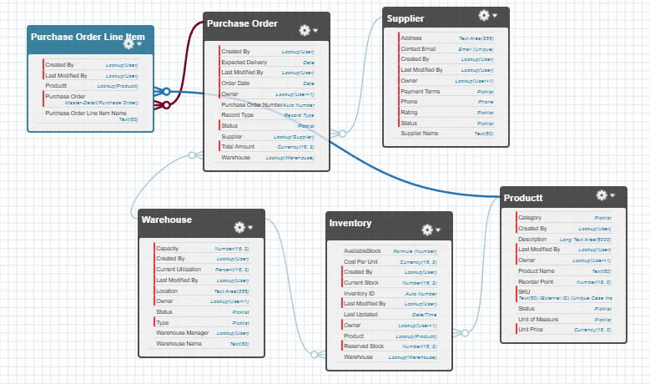

**Summary**

Phase 3 delivers a robust Salesforce data architecture tailored for supply chain & inventory management. All necessary custom objects, fields, record types, layouts, and relationships are in place, ready for process automation and UI customization in subsequent phases.